

**ORACLE DATABASE VAULT**

**implement oracle vault in database:**

**Step 1-1: Verify Prerequisites:**

-Verify that your database is in ARCHIVELOG mode:

SQL> SELECT log_mode FROM v$database;

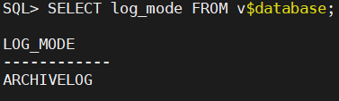

-Check if Oracle Label Security (OLS) is enabled, as Database Vault requires it, If it is not installed, you must enable it.

SQL>

SELECT COMP_NAME, VERSION, STATUS FROM dba_registry WHERE comp_id='OLS';

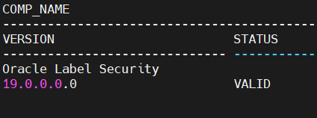

**Step 1-2: Check whether DB Vault is enabled:**

SQL> select * from v$option where lower(PARAMETER) like '%vault%';

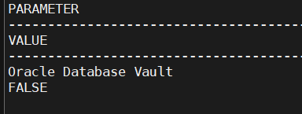

SQL> select * from dba_dv_status;

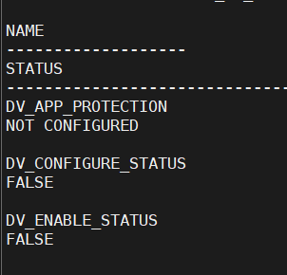

**Step 2-1: Users to manage database vault:**

SQL>

create user c##dvowner identified by <password>;

create user c##dvactmgr identified by <password>;

to set configuration for users

BEGIN

 DVSYS.CONFIGURE_DV (

 dvowner_uname => 'c##dvowner',

 dvacctmgr_uname => 'c##dvactmgr');

END;

/

**Step 2-2: to enable database vault:**

SQL> conn c##dvowner/dvowner

EXEC DBMS_MACADM.ENABLE_DV;

execute dvsys.dbms_macadm.enable_app_protection(NULL);

EXEC DBMS_MACADM.DISENABLE_APP_PROTECTION;

EXEC DBMS_MACADM.ENABLE_APP_PROTECTION ('PDB_NAME');

**Step 2-3: restart database to confige database vault:**

SQL> conn / as sysdba

SQL> shutdown immediate

SQL> startup

SQL> alter pluggable database all open;

SQL> select * from dba_dv_status;

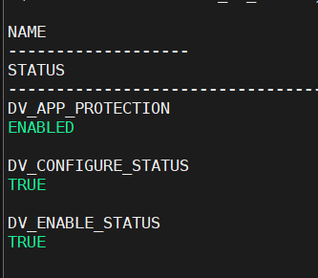

**Step 3-1: Define Realms, Command Rules, and Factors:**

Steps to Prevent Access Example: -

1. Create a Database Vault Realm

Create a realm specifically to protect these 3 tables.

BEGIN

   DBMS_MACADM.CREATE_REALM (

      realm_name       => 'Protect_bank_Tables',

      description      => 'Protect table1, table2, and table3 in the bank schema',

      enabled          => DBMS_MACUTL.G_YES

   );

END;

/

2. Add the Specific Tables to the Realm

Add only the 3 tables to the realm

BEGIN

   -- Add table1

   DBMS_MACADM.ADD_OBJECT_TO_REALM(

      realm_name       => 'Protect_bank_Tables',

      object_schema    => 'BANK',

      object_name      => 'TABLE1',

      object_type      => 'TABLE'

   );

   -- Add table2

   DBMS_MACADM.ADD_OBJECT_TO_REALM(

      realm_name       => 'Protect_bank_Tables',

      object_schema    => 'BANK',

      object_name      => 'TABLE2',

      object_type      => 'TABLE'

   );

   -- Add table3

   DBMS_MACADM.ADD_OBJECT_TO_REALM (

      realm_name       => 'Protect_bank_Tables',

      object_schema    => 'BANK',

      object_name      => 'TABLE3',

      object_type      => 'TABLE'

   );

END;

/

3. Use Database Roles for Fine-Grained Privileges

Create a role for users who need access

CREATE ROLE bank_read_role;

GRANT SELECT ON bank. <table_name> TO bank_read_role;

2.Assign this role only to specific users:

GRANT bank_read_role TO user_allowed_access;

4.audit

AUDIT SELECT, INSERT, UPDATE, DELETE ON bank. <table_name> BY ACCESS;

**Step 3-2: Optionally Restrict SYS from Performing Administrative Actions:**

A) Create a Database Vault Realm for SYS

- Switch to secure_admin (Database Vault Owner) and create a realm to restrict SYS from modifying system objects:

BEGIN

  DVSYS.DBMS_MACADM.CREATE_REALM(

    realm_name    => 'Restrict SYS Realm',

    realm_desc    => 'Prevents SYS from accessing sensitive data',

    enabled       => DBMS_MACUTL.G_YES

  );

END;

/

B) Add SYS-Related Objects to the Realm

- Protect important schemas (like SYS, SYSTEM):

- This prevents SYS from modifying any table in the SYS schema.

BEGIN

  DVSYS.DBMS_MACADM.ADD_REALM_OBJECT(

    realm_name   => 'Restrict SYS Realm',

    object_owner => 'SYS',

    object_name  => '%',

    object_type  => 'TABLE'

  );

END;

/

Prevent SYS from Running Critical Commands

==================================================

- Create a Command Rule to block SYS from executing certain commands:

A) Block SYS from Creating Users Example

BEGIN

  DVSYS.DBMS_MACADM.CREATE_COMMAND_RULE(

    command        => 'CREATE USER',

    rule_name      => 'Block SYS Create User',

    object_owner   => NULL,

    object_name    => NULL,

    rule_expr      => 'SYS_CONTEXT (''USERENV'', ''SESSION_USER'')!= ''SYS''',

    enabled        => DBMS_MACUTL.G_YES

  );

END;

/

B) Block SYS from Executing DDL Statements, This prevents SYS from executing ALTER SYSTEM commands.

BEGIN

  DVSYS.DBMS_MACADM.CREATE_COMMAND_RULE (

    command        => 'ALTER SYSTEM',

    rule_name      => 'Block SYS Alter System',

    object_owner   => NULL,

    object_name    => NULL,

    rule_expr      => 'SYS_CONTEXT(''USERENV'', ''SESSION_USER'') != ''SYS''',

    enabled        => DBMS_MACUTL.G_YES

  );

END;

/